September 29, 2024

Keith Jhaeron Cayatoc

B.I.T Student

Nelson Marlborough Institute of Technology

WEB701 Assessment 1 Milestone 2

Tutor: Todd Cochrane

# Purpose of Web Frameworks and Their Role in Website Development

## Introduction

A web framework is a software tool that provides developers with a structured environment to build and manage web applications more efficiently. Instead of coding every aspect of a website from scratch, web frameworks offer reusable code components and tools that handle common tasks such as routing, database management, security, and user authentication. This allows developers to focus on the specific features of an application while the framework takes care of repetitive tasks.

## Purpose of Web Frameworks

Web frameworks simplify the development process by providing pre-built modules and templates. This reduces the amount of custom code a developer has to write and make sure that they can follow best practices more easily. One of the main purposes of a web framework is to speed up development by offering solutions to common problems such as how to route URLs, interact with databases, or/and ensure security.

For example, frameworks like Django provide built-in tools for user authentication and authorization, which is very important for websites that require users to log in or manage personalized accounts. Additionally, web frameworks ensure that websites are scalable, allowing them to grow and handle more traffic as the user base increases. Another benefit is that frameworks encourage cleaner, more organized code, making it easier for teams of developers to collaborate on large projects.

## Common Features of Web Frameworks

Most web frameworks offer a range of features that simplify the creation and management of web applications and most common features include:

1. **Routing –** Routing is how a web application maps URLs to specific parts of the program. An example of this is when a user types in a URL into their browser, the framework routes that URL to the correct part of the application. This makes it easier to manage different pages of a website, such as the home page, login page, or program descriptions.
2. **Database Interaction (ORM) –** Many frameworks offer an Object-Relational Mapping (ORM) system that allows developers to interact with databases without writing complex SQL queries. With an ORM, developers can create, read, update, and delete data from the database using code that’s easier to understand and maintain.
3. **Authentication and Authorization –** Security is one of the main and very important aspect of web development, and most frameworks provide built-in tools to manage user authentication (login systems) and authorization (what users are allowed to do). These tools help ensure that only authorized users can access sensitive information or features.
4. **Templating Systems –** Web frameworks often include templating systems that help developers dynamically generate HTML pages. This is useful when building websites with user-specific content, such as dashboards or personalized program recommendations. Templating allows the website to present different data depending on who is logged in or what information they are accessing.
5. **Form Handling and Validation -** Another important feature is form handling. Many websites need users to submit forms, whether it's a registration form or a donation page. Web frameworks provide built-in form handling and validation tools to ensure that the data entered by users is correct and securely submitted.

## Specific Frameworks Used in the Website Scenario

For the Youth Empowerment Network website, we need a framework that can support multiple user types like youth participants, mentors, and program coordinators, manage dynamic content like events, programs, and mentorship sessions, as well as making sure that the user data has a maximum amount of security.

One option is Django, a Python-based framework known for its simplicity and powerful features. Django offers an out-of-the-box solution for user authentication and has a built-in admin panel that can be used to manage users, events, and program details. This framework’s ORM system makes it easy to interact with a database without needing to write complex SQL queries. Since Django enforces best practices and security, it is ideal for handling sensitive data, such as user profiles and program progress.

Another option is React combined with Express.js (Node.js). React is a JavaScript library used for building dynamic, interactive user interfaces while Express.js handles the back-end logic and APIs. This combination allows us to build a highly flexible front-end where users can view personalized dashboards, register for events, and interact with program data in real time. React’s component-based structure makes it easy to develop reusable parts of the site, such as a registration form or a mentorship booking system.

## How will these Frameworks fit into the project

The Youth Empowerment Network website requires robust user authentication and role-based access control to ensure that youth participants, mentors, and coordinators can access the correct sections of the site. Django offers an excellent solution here, as its built-in authentication system allows for secure user registration and login, along with permission settings for different user roles. The website’s admin panel can be used to update program information, approve new mentors, and track the progress of participants in various programs.

On the other hand, React paired with Express.js would give us more control over the user interface. This is important for features like interactive event calendars or the ability to browse mentors and book meetings. React allows us to create a smooth and intuitive user experience, which is essential when trying to engage young people in mentorship and career development opportunities.

An example of this is when a participant logging in might immediately see a personalized dashboard showing their upcoming mentorship sessions, the programs they’re enrolled in, and recommended events based on their interests. React’s dynamic updating capabilities mean that this data can be refreshed in real time without requiring the user to reload the page.

# Introducing Progressive Web Apps (PWAs): Enhancing Accessibility and User Engagement for the Youth Empowerment Website

## Describe and identify emerging web technology

The emerging web technology I have selected is PWA also known as Progressive Web Applications.

Progressive Web Apps (PWAs) are a type of web application that offer a native app-like experience through the browser that combines the best features of web and mobile apps. PWAs are designed to work offline, load quickly, and provide seamless user interactions, regardless of the user’s network conditions.

One of the key benefits of PWAs is their ability to work offline by caching essential parts of the website. This allows users to access content even when they lose internet connectivity. PWAs also support push notifications, allowing websites to engage users more effectively by sending them real-time updates. By offering an engaging and accessible experience, PWAs are revolutionizing how users interact with web applications.

## How can the selected web technology be implemented in the Youth Empowerment website

The Youth Empowerment website targets a wide range of users which mostly includes young participants, mentors, and program coordinators. Many of these users may access the website from mobile devices or from areas with limited internet connectivity. PWAs were selected because they allow offline access to important resources making sure that users can still engage with the site even if they experience connectivity issues.

To investigate the implementation of PWAs, I reviewed various resources, including Google's documentation on PWAs and an article about the rise of progressive web apps, which outlines best practices for caching strategies and service workers. I also explored several tutorials on web.dev and tested demo PWAs to understand how offline access and push notifications function. These resources provided insights into how PWAs could improve the user experience on the Youth Empowerment website.

The PWA will be implemented using a service worker which caches important pages like the mentorship program details, resources, and event schedules. This will allow users to browse key sections of the website while offline. Additionally, push notifications will be enabled to remind users of upcoming events and newly added resources keeping them engaged with the website.

## Impact of the selected web application on internet users

For users of the Youth Empowerment website, the implementation of a PWA will significantly enhance their experience. By allowing offline access to key parts of the site, users in areas with unstable or slow internet connections will still be able to browse mentorship programs, access resources, and register for events without disruption. This feature will be useful for young participants who rely on mobile devices and may not always have access to a stable connection. The use of push notifications will further increase engagement by allowing the website to send reminders about upcoming mentorship sessions or newly published resources. This will keep users informed and engaged even when they are not actively browsing the site.

On a broader scale, PWAs are reshaping the way users interact with web applications. By providing an app-like experience directly from the browser, PWAs eliminate the need for users to download native apps that leaves to saving storage space on devices. As more websites adopt PWA technology, users will come to expect faster loading times, offline functionality, and seamless interactions across all web applications. This shift will likely lead to a broader adoption of mobile-first, highly accessible web applications that enhance user experience across the internet.

HubSpot. (2023, January 31). *Web development trends to watch in 2023*. HubSpot. <https://blog.hubspot.com/website/web-development-trends>

# Evaluation and Comparison of Web Frameworks: MEAN vs MERN stack for Youth Empowerment Website

## MEAN stack framework

### User registration and authentication

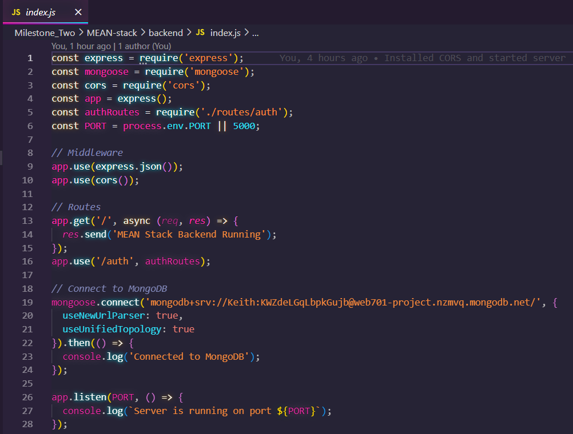

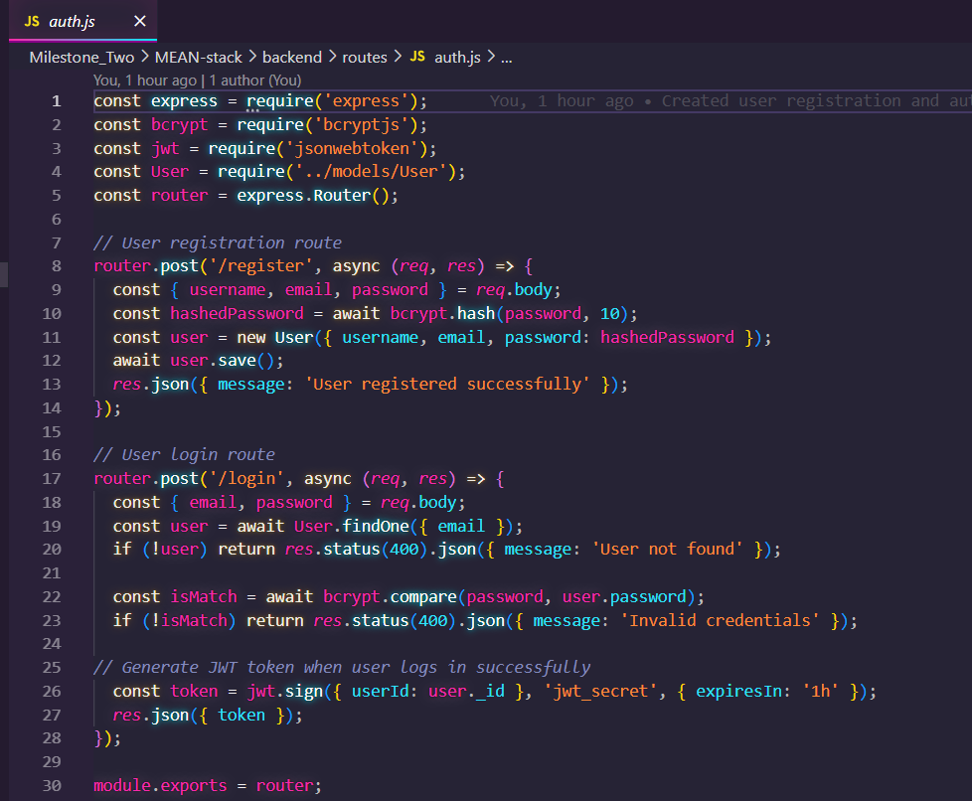

### System Interface (frontend code)

**Login component**

### 

**HTTP request handler and authentication manager**

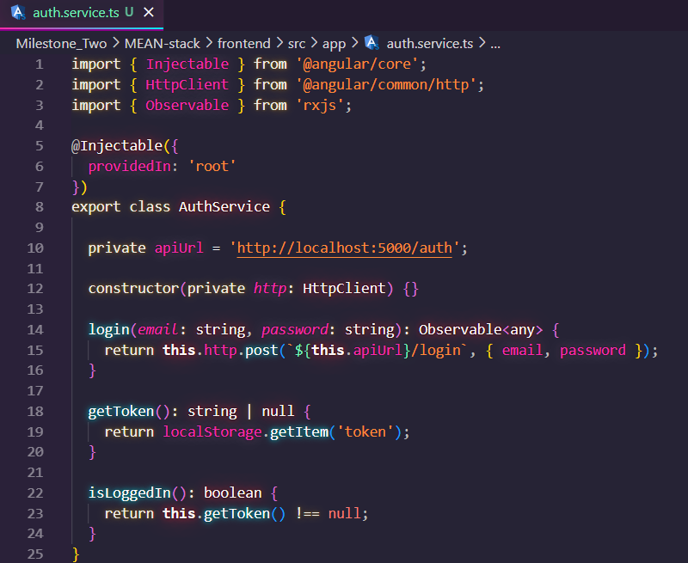

**Adding protected route in Angular**

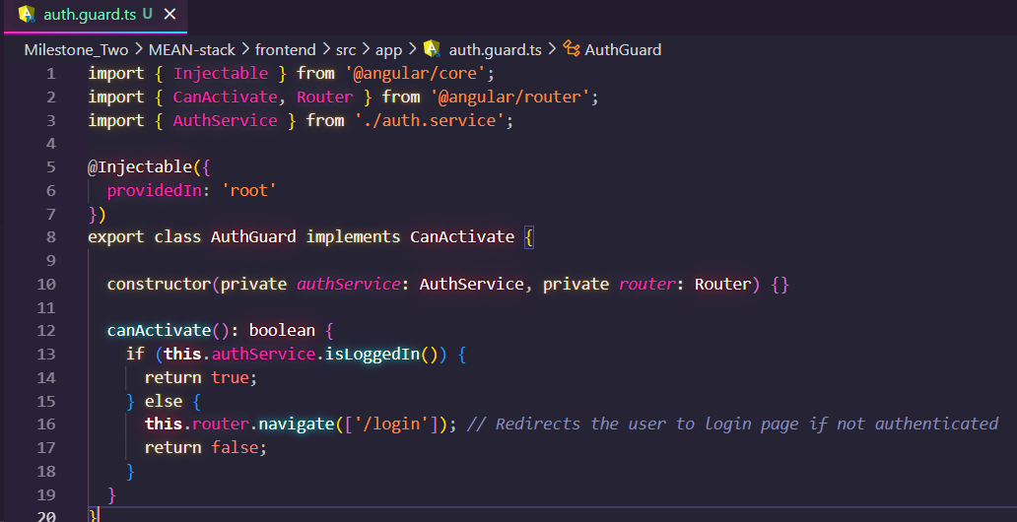

### User Data Storage and Retrieval

**Product/Service Schema**

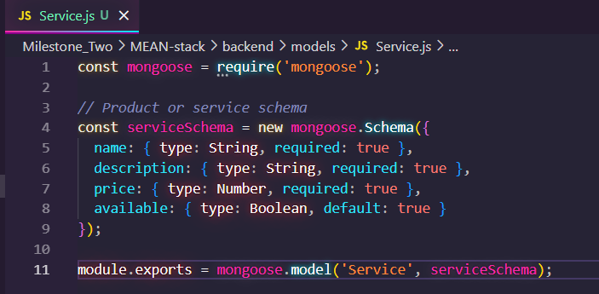

**Product/Service Routes**

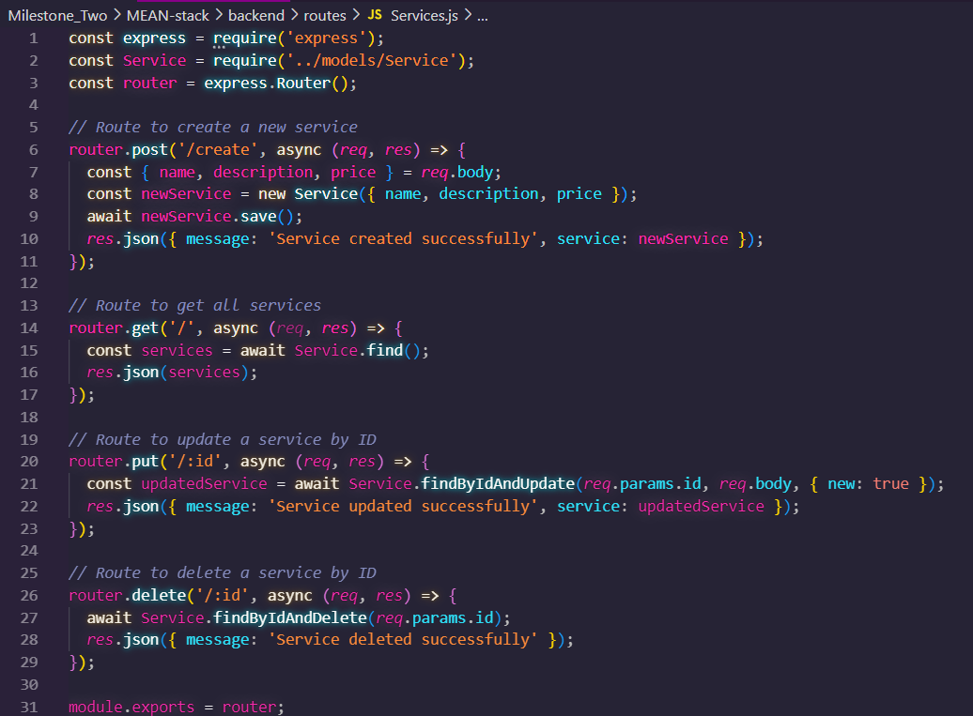

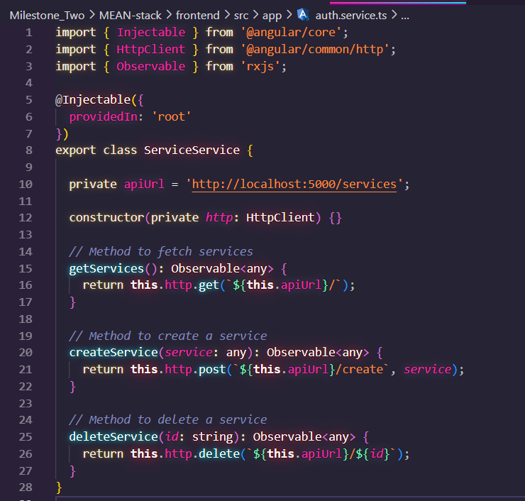

## MERN stack Framework

### User Authentication with JWT

**Index.js**

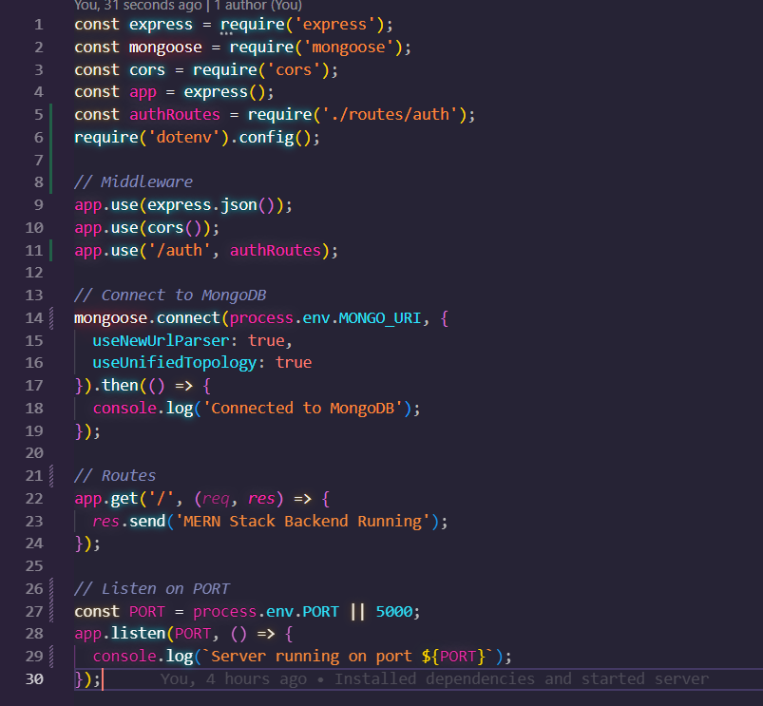

**User.js**

**Auth.js**

**Register.js (frontend)**

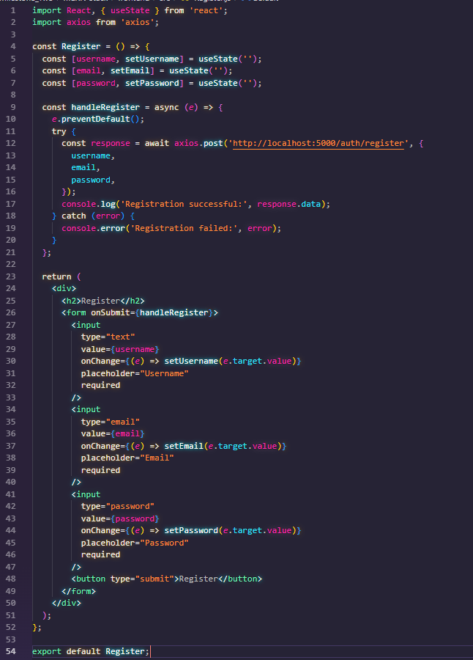

**App.js (frontend)**

### Token-based Transactions

**Tokens.js**

**Dashboard for token transaction (frontend)**

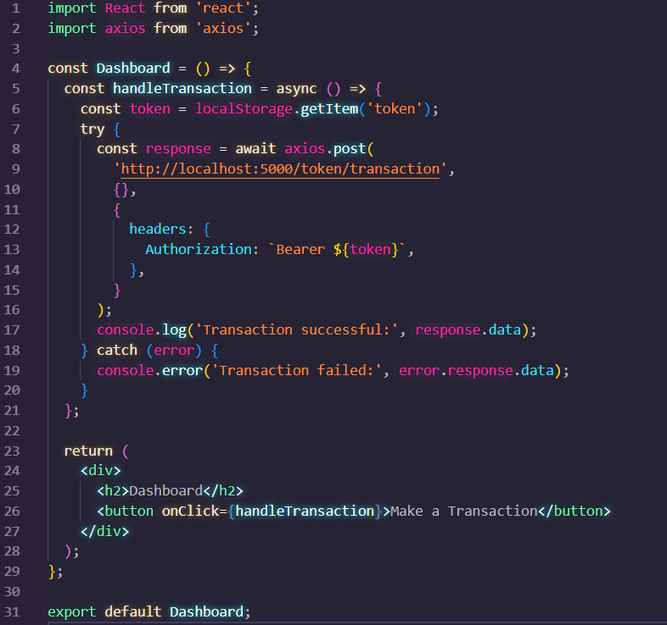

### CRUD operations for user profile data

**User.js**

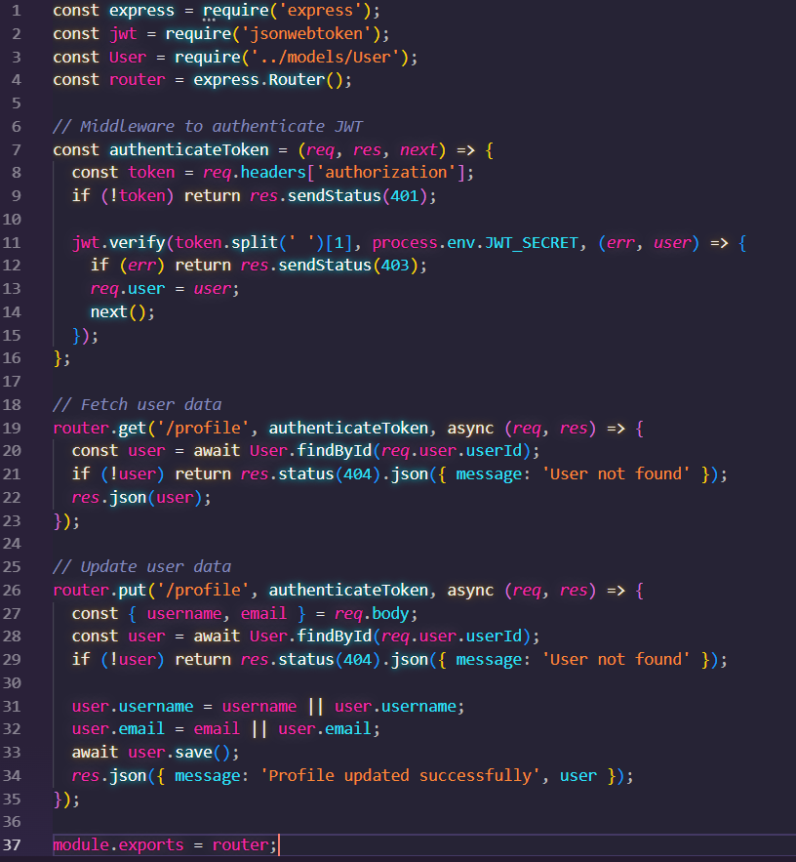

**Profile.js (frontend)**

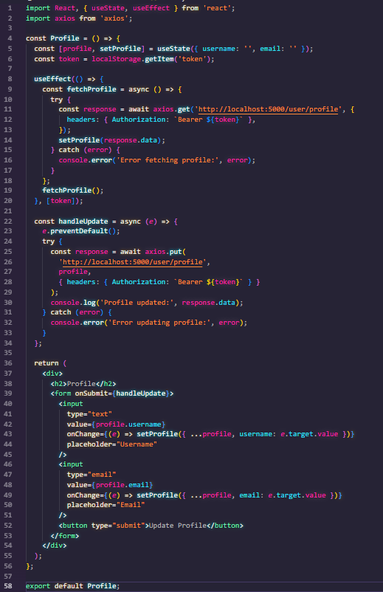

# Conclusion and Recommendation

After evaluating both the MEAN and MERN stack frameworks for the Youth Empowerment Website project, I recommend using the MERN stack for the development of the website. This decision is based on the specific pros and cons of each stack, as well as the suitability of the MERN stack for this project’s needs.

## Pros and Cons of MEAN stack

|  |  |
| --- | --- |
| **PROS** | **CONS** |
| Easier to learn and maintain as developers do not need to switch between different languages because it uses JavaScript throughout the development. | Angular's steep learning curve compared to React can be challenging for developers who are new to the framework as it requires knowledge of TypeScript, RxJS, and other advanced concepts. |
| Angular provides a structured framework with built-in solutions for routing, form validation, and dependency injection. It is beneficial for larger applications that requires a strict structure. | Angular can introduce additional overhead for smaller projects where a more lightweight framework might be preferable. |
| Angular is a mature framework backed by Google with a large developer community, which ensures long-term stability and frequent updates. |

## Pros and Cons of MERN stack

|  |  |
| --- | --- |
| **PROS** | **CONS** |
| React offers more flexibility and a lower learning curve than Angular. Its component-based structure makes it easier to create reusable UI components, this is ideal for a project like this with dynamic content. | React is less opinionated than Angular, which means developers need to rely on external libraries for features like routing and state management for example Redux. This can lead to varying development approaches within a team unless best practices are clearly defined. |
| React’s virtual DOM enhances the performance of applications, making it faster when dealing with dynamic user interfaces. | React may have a large community but some might argue that the enterprise-level support from Facebook is not as extensive as Angular's backing from Google. |
| MERN benefits from a large ecosystem of third-party libraries and tools due to React's widespread adoption | With REACT being a client-side rendering framework it can be a challenge to have SEO (Search Engine Optimization) if not configured properly for server-side rendering. |

## Why I choose MERN stack over MEAN stack

The MERN stack offers several advantages that align with the goals and scope of the Youth Empowerment Website:

1. **Ease of Use:** The lower learning curve of React will allow faster implementation and easier onboarding of future developers. React’s component-based architecture also fits well with the dynamic and modular nature of the website, where different sections like user registration and community engagement can be developed independently.
2. **Performance:** The project requires efficient handling of user data and dynamic content, which React’s virtual DOM is well-suited for. The need for fast loading times and a responsive user experience makes React the better choice in this case.
3. **Scalability:** The flexibility of the MERN stack allows it to scale well with the project's growth. As the Youth Empowerment Website expands its features, for example, adding more complex user interactions and real-time data the modular nature of React will enable easy updates and scalability.

By selecting the MERN stack the project is expected to be developed with the right balance of flexibility, performance, and ease of use making it the most suitable choice for the Youth Empowerment Website.

# References

Django Software Foundation. (2023). *Django documentation*. Retrieved from <https://docs.djangoproject.com/en/stable/>

Facebook. (2023). *React: A JavaScript library for building user interfaces*. Retrieved from <https://reactjs.org/docs/getting-started.html>

Mozilla Developer Network. (2023). *Introduction to web frameworks*. Retrieved from <https://developer.mozilla.org/en-US/docs/Learn/Server-side/Frameworks>

Express.js Foundation. (2023). *Express.js documentation*. Retrieved from <https://expressjs.com/>

PWA Documentation. (2023). *Progressive Web Apps (PWAs): What are they?* Retrieved from <https://web.dev/progressive-web-apps/>

HubSpot. (2023, January 31). *Web development trends to watch in 2023*. HubSpot. <https://blog.hubspot.com/website/web-development-trends>

GraphQL Foundation. (2023). *GraphQL: A query language for your API*. Retrieved from <https://graphql.org/learn/>

*The rise of progressive web apps: Revolutionising the mobile experience | Insights | Koda web design*. (n.d.). Koda Web Design Auckland NZ - Web Development Specialists. <https://www.kodaweb.co.nz/blog/rise-progressive-web-apps-revolutionising-mobile-experience>

Google Developers. (2023). *Progressive Web Apps documentation*. Retrieved from <https://web.dev/progressive-web-apps/>

Faulkner, J. (2020). MERN vs MEAN: Which Full-Stack Should You Choose? Retrieved from <https://example.com/article-mern-vs-mean>

Md Mizanur Rahman. (2022). Why MERN Stack is Preferred Over MEAN Stack. Retrieved from <https://example.com/mern-preferred-over-mean>